* Create SQL Database page and fill the details while also making the server with userid and password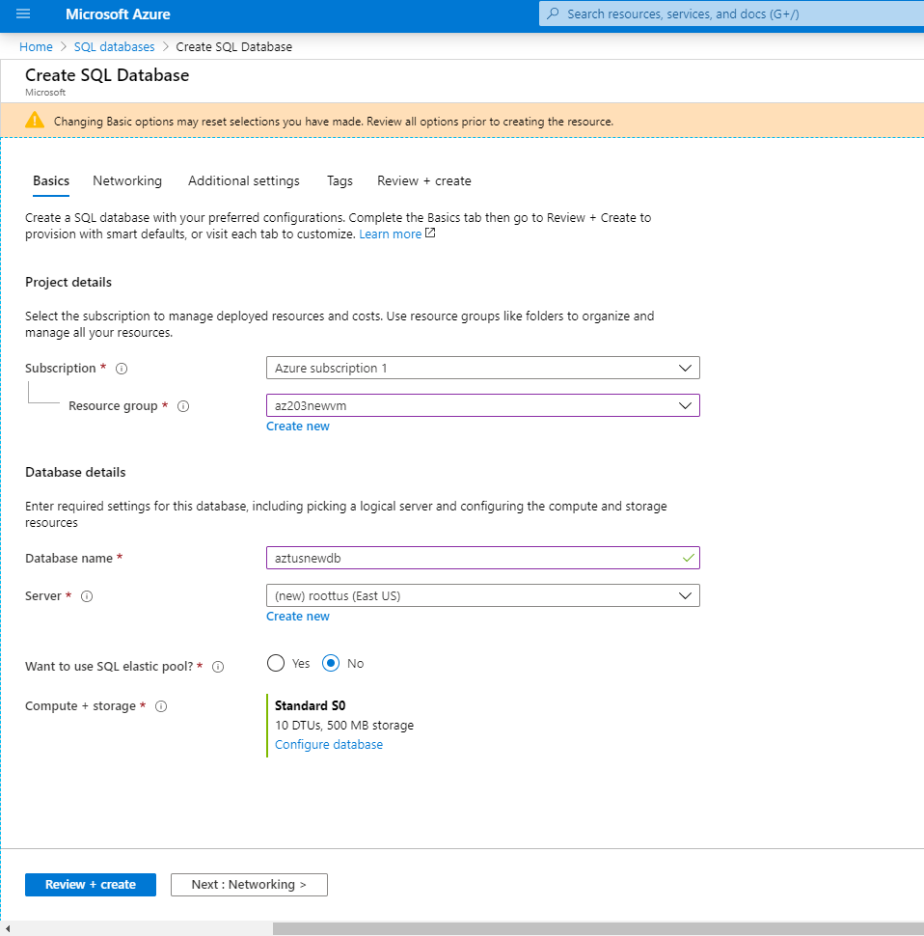
* We can also point the backup file for the DB for preloaded data.
* ``Database created 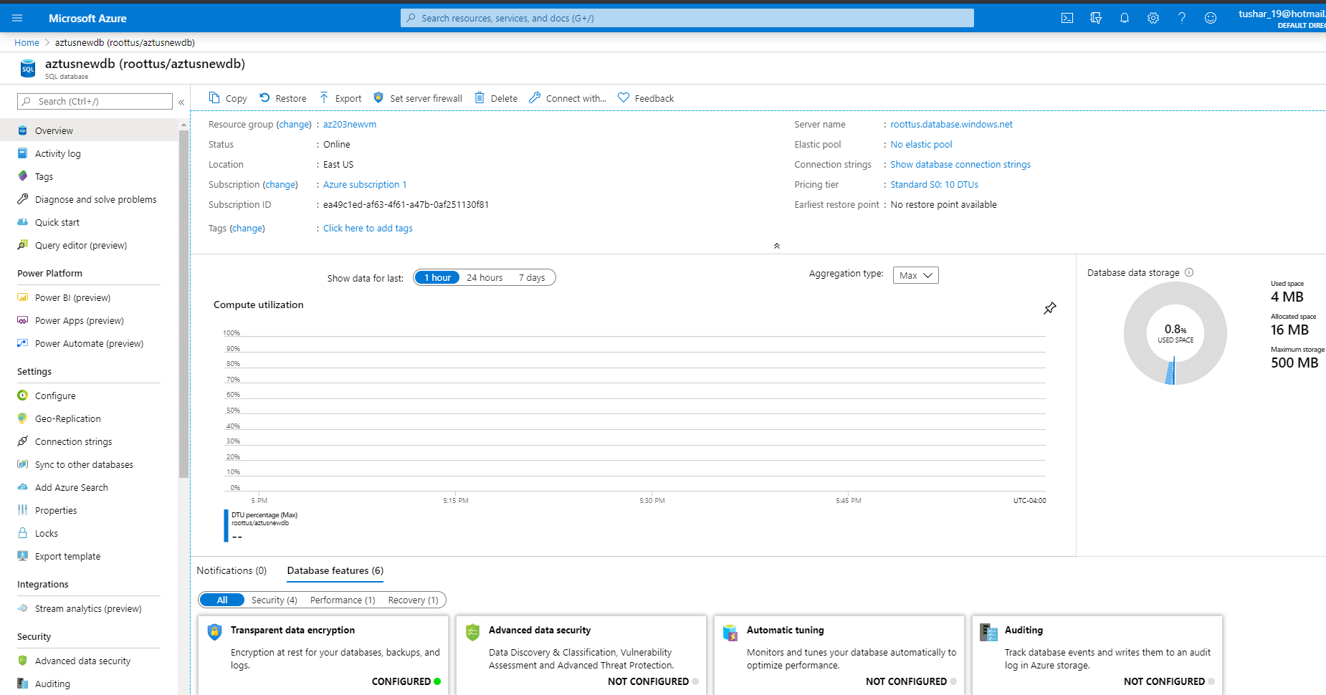
* We can also turn on the checkbox to use allow if you want other services to interact with this database.
* SQL Elastic pool, Pool multiple databases sharing same resource. This way we can reduce the replication of data for all databases.
* Pricing model for Databases <https://docs.microsoft.com/en-in/azure/sql-database/sql-database-purchase-models>
* Add Ip to the firewall to access the database.
* 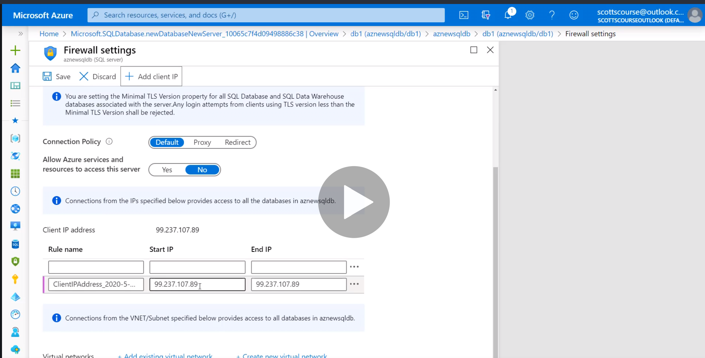
* After that we can login to database with the admin password.
* A Database is connected to the Azure SQL Server.
* We can download Microsoft SQL Server Management Studio to manage Azure Cloud database and server from your desktop.
* Management Studio is just like MySql Workbench.